Chapter 1
INTRODUCTION

In India, natural disasters like earthquakes, floods, cyclones, landslides, and fires pose serious threats to infrastructure and human life. Because they regularly house sizable numbers of employees and students, educational institutions are especially susceptible to disasters. There are frameworks for disaster management at the national level, but there is still little organized implementation in schools and universities. In order to improve resilience and lessen the effects of disasters, the National Disaster Management Authority (NDMA) places a strong emphasis on incorporating disaster preparedness education into school systems [1].

In order to enhance preparedness and response capabilities, this project aims to create a Disaster Preparedness and Response Education System for Schools and Colleges that makes use of digital technologies, simulation-based training, and region-specific awareness.

1.1 Background
India is extremely vulnerable to natural disasters due to its diverse geography and climate. In order to develop policies, guidelines, and best practices for disaster risk reduction and preparedness, the Indian government established the National Disaster Management Authority (NDMA). In order to lessen vulnerability and increase resilience, NDMA stresses the significance of incorporating disaster management education into school systems.
Many educational institutions lack organized disaster preparedness programs, even in the face of policy frameworks like the NDMA's School Safety Policy Guidelines. The majority of institutions rely on sporadic awareness sessions or manual drills, which don't offer regular or useful exposure to emergency response protocols.

Disaster risk reduction education is essential for fostering youth resilience and lessening the effects of disasters, according to UNESCO. The efficacy of current preparedness efforts is, however, constrained by the lack of digital simulation tools and monitoring systems. To close this gap and guarantee systematic training, a thorough digital disaster preparedness education system is required.
References:
[1] National Disaster Management Authority (NDMA), Government of India, School Safety Policy Guidelines, Available: https://ndma.gov.in
[2] UNESCO, Disaster Risk Reduction in School Systems, United Nations Educational, Scientific and Cultural Organization, Available: https://www.unesco.org
1.2 Statistics
India is considered one of the most disaster-prone countries in the world. According to the National Disaster Management Authority (NDMA), approximately 58.6% of India’s landmass is prone to earthquakes, nearly 12% is vulnerable to floods and river erosion, about 68% of cultivable land is susceptible to drought, and around 5,700 km of coastline is exposed to cyclones and tsunamis [1]. These statistics indicate the high level of disaster vulnerability across different regions of the country.
The United Nations Office for Disaster Risk Reduction (UNDRR) reports that disasters affect millions of people annually and emphasizes that preparedness education significantly reduces disaster-related casualties and economic losses. The report highlights that proactive preparedness measures in schools can greatly improve emergency response and minimize risks [2]. These statistics demonstrate the urgent need for a structured disaster preparedness education system in schools and colleges.
References (1.2 Statistics)
[1] National Disaster Management Authority (NDMA), Government of India, Disaster Management in India, Available: https://ndma.gov.in
[2] United Nations Office for Disaster Risk Reduction (UNDRR), Global Assessment Report on Disaster Risk Reduction, Available: https://www.undrr.org
1.3 Prior Existing Technologies
Existing disaster preparedness technologies primarily include government-issued safety guidelines, awareness campaigns, early warning systems, and mobile alert applications. NDMA provides disaster preparedness manuals, emergency response guidelines, and safety training materials for institutions through official portals [1]. These resources focus mainly on awareness and policy-level guidance.
Additionally, government-supported early warning systems and disaster alert mobile applications provide real-time notifications and emergency information to citizens. While these systems are effective for alert dissemination, they lack structured educational modules, simulation-based training, and monitoring systems tailored specifically for schools and colleges [2].
UNESCO has highlighted that interactive and technology-enabled learning approaches are more effective than traditional theoretical awareness programs in improving disaster preparedness [3]. Therefore, existing technologies do not provide an integrated digital platform that combines education, simulation, and institutional preparedness assessment.
References (1.3 Prior Existing Technologies)
[1] National Disaster Management Authority (NDMA), Government of India, Disaster Management Guidelines, Available: https://ndma.gov.in
[2] Government of India, National Disaster Early Warning Systems, Available: https://www.india.gov.in
[3] UNESCO, Disaster Risk Reduction and Education, Available: https://www.unesco.org
1.4 Proposed Approach
The primary aim of this project is to design and develop a Disaster Preparedness and Response Education System for Schools and Colleges that provides a structured, technology-driven platform for disaster awareness and emergency response training. The system seeks to integrate disaster preparedness education into institutional environments through digital learning modules, virtual simulations, and region-specific safety guidelines. The objective is to enhance preparedness, improve response efficiency, and promote a culture of safety among students and staff.
Motivation:
Educational institutions in India remain vulnerable to natural and man-made disasters due to inadequate preparedness training and limited practical exposure. Although disaster management policies exist, their implementation in schools and colleges is often restricted to theoretical awareness sessions and occasional drills. Many students are unaware of correct emergency procedures, which may lead to panic and confusion during real disaster situations.
With increasing disaster frequency due to climate change, rapid urbanization, and infrastructure expansion, the need for systematic and continuous preparedness education has become critical. Advances in digital technology and simulation-based learning provide an opportunity to create interactive and engaging training environments that can significantly improve understanding and retention. This project is motivated by the need to bridge the gap between disaster management policies and practical institutional preparedness.
The proposed system is a web-based digital platform designed to deliver structured disaster preparedness education through interactive and simulation-based learning. The approach consists of the following components:
- Educational Modules – Structured content covering various types of disasters such as earthquakes, floods, fires, and cyclones, including safety protocols and emergency response procedures.
- Virtual Disaster Simulations – Interactive simulations that allow students and staff to experience realistic disaster scenarios in a controlled digital environment, enabling practical learning without physical risk.
- Region-Specific Preparedness Information – Customized modules based on local disaster risks to ensure relevant and contextual training.
- Virtual Drill Management – Tools for institutions to conduct scheduled digital drills and track participation.
- Monitoring and Assessment System – Administrative dashboard to evaluate preparedness levels, generate reports, and assess learning outcomes.
This integrated approach ensures continuous learning, practical exposure, and institutional monitoring, thereby improving disaster readiness in a structured manner.
Applications of the Project:
The proposed system can be applied in multiple contexts, including:
- Schools for student safety education and preparedness training
- Colleges and universities for large-scale disaster awareness programs
- Government and disaster management authorities for institutional training initiatives
- Teacher training institutes for disaster preparedness workshops
- Private and public educational institutions seeking structured safety compliance
The system can also be scaled for use in other public institutions such as offices and community centers.
Limitations of the Proposed Approach:
Despite its advantages, the proposed system has certain limitations:
- Requires reliable internet connectivity and access to digital devices
- Virtual simulations may not fully replicate real-life physical conditions
- Initial development and deployment may require technical resources and funding
- Effectiveness depends on regular usage and institutional commitment
- Users may require basic digital literacy to operate the system efficiently
If you want, I can now prepare the System Architecture Diagram explanation or Methodology section in the same academic format for your report submission.
1.5 Objectives
Objective 1: Behaviour
Develop an interactive disaster preparedness system that allows students and staff to learn and respond to simulated disaster scenarios such as earthquakes, floods, and fires through guided instructions and virtual drills in a user-friendly interface.
Objective 2: Analysis
Implement a disaster risk analysis and region-based classification mechanism to categorize disaster types and provide customized preparedness content based on geographic vulnerability and institutional requirements.
Objective 3: System Management
Design a structured backend database and administrative dashboard to store, manage, schedule, and monitor disaster training modules, drill participation records, and preparedness assessment reports.
Objective 4: Security
Ensure data protection and system integrity by implementing secure authentication, role-based access control (Admin, Teacher, Student), and protected data storage to prevent unauthorized access or modifications.
Objective 5: Deployment
Deploy the system as a web-based application accessible across devices (desktop, tablet, and mobile), ensuring scalability, centralized data management, and reliable performance for multiple institutions.
1.6 SDGs
The Disaster Preparedness and Response Education System for Schools and Colleges align with the United Nations Sustainable Development Goals (SDGs) as illustrated in Fig 1.1. The project supports safety education, disaster risk reduction, and digital innovation in educational institutions.
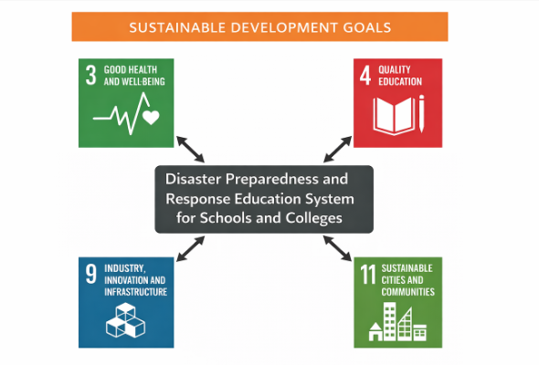
Fig 1.1 Sustainable development goals

SDG 3 – Good Health and Well-being
By providing disaster preparedness training and emergency response education, the system helps reduce injuries and health risks during disasters, promoting preventive safety practices (United Nations, 2023a).
SDG 4 – Quality Education
The platform serves as a structured digital learning tool that integrates disaster education into schools and colleges, promoting inclusive and quality education (United Nations, 2023b).
SDG 11 – Sustainable Cities and Communities
By improving institutional disaster readiness, the project contributes to building resilient communities and reducing disaster impact (UNDRR, 2022).
SDG 9 – Industry, Innovation, and Infrastructure
The use of a web-based digital platform demonstrates innovation in disaster education and supports resilient knowledge infrastructure (United Nations, 2023c).
Assessment of SDG Alignment
The project contributes to disaster risk reduction, health protection, educational enhancement, and community resilience. By integrating digital preparedness training in institutions, it supports sustainable development through prevention and awareness
References (1.6 SDGs)
United Nations. (2023a). Sustainable Development Goal 3: Good Health and Well-being. Available at: https://sdgs.un.org/goals/goal3
United Nations. (2023b). Sustainable Development Goal 4: Quality Education. Available at: https://sdgs.un.org/goals/goal4
United Nations Office for Disaster Risk Reduction (UNDRR). (2022). Sendai Framework for Disaster Risk Reduction.
United Nations. (2023c). Sustainable Development Goal 9: Industry, Innovation and Infrastructure. Available at: https://sdgs.un.org/goals/goal9
1.7 Overview of project report
This report presents a comprehensive documentation of the Disaster management and preparedness project covering all aspects from conceptualization through implementation and validation.
Chapter 1 provides an introduction to the project titled Disaster Preparedness and Response Education System for Schools and Colleges, including the background, relevant statistics, prior existing technologies, proposed approach, objectives, alignment with Sustainable Development Goals (SDGs), and overall scope of the study.
Chapter 2 presents a detailed literature review, analyzing existing disaster management systems, digital education platforms, and simulation-based training technologies, while identifying research gaps addressed by the proposed system.
Chapter 3 describes the methodology adopted for the project, including system architecture, development model, algorithm, and module design.
Chapter 4 covers project management aspects such as timeline planning, risk analysis, and project budgeting to ensure structured implementation.
Chapter 5 focuses on system analysis and design, including requirements specification, functional block diagrams, system flowcharts, software standards, and overall system structure. Together, these chapters provide a comprehensive understanding of the design, development, and implementation of the proposed disaster preparedness education system.

Chapter 2
Literature review
In this chapter, existing research related to disaster preparedness education systems, simulation-based training, early warning systems, and policy frameworks is reviewed. The objective is to analyze their methodologies, outcomes, and limitations to justify the development of the proposed Disaster Preparedness and Response Education System for Schools and Colleges.
2.1 Digital Disaster Preparedness Education Systems
The Virtual Disaster Training System for School Safety (IEEE, 2021) introduced a web-based platform with scenario-based modules for earthquakes and fires. The system used interactive decision-making exercises and evaluation metrics to measure response accuracy. Results showed improved awareness and evacuation speed during drills. However, it lacked regional customization, institutional dashboards, and scalability features.
Similarly, the E-Learning Framework for Disaster Risk Reduction (Elsevier, 2019) integrated disaster education into an LMS using multimedia content and quizzes. While it improved theoretical understanding, it lacked practical simulation modules and real-time performance analytics. The study recommended combining structured learning with experiential simulation tools.
2.2 Virtual Reality and Simulation-Based Training
The Immersive VR-Based Fire Evacuation Training (ACM, 2020) developed a 3D virtual environment for evacuation training. The system improved engagement and knowledge retention but required expensive hardware, limiting large-scale adoption.
The Gamified Disaster Learning Platform (Springer, 2022) used interactive reward-based mechanisms to enhance participation. Although engagement improved, the system lacked institutional monitoring, regional adaptation, and compliance tracking features.
2.3 IoT and Early Warning Systems
The IoT-Enabled Smart Evacuation Monitoring System (IEEE IoT Journal, 2022) focused on sensor-based infrastructure monitoring for fire and smoke detection. While effective for real-time alerts, it did not address disaster education or behavioural preparedness.
Similarly, the Mobile-Based Disaster Alert and Geo-Notification System (Springer, 2021) provided GPS-based emergency alerts. Although efficient in communication, it lacked structured training modules and institutional assessment tools.
2.4 Policy and Framework-Based Approaches
The Sendai Framework for Disaster Risk Reduction (UNDRR, 2022) emphasizes integrating disaster preparedness into education systems. However, it provides policy guidelines rather than technological implementation models.
The Cloud-Based Disaster Management Information System (IEEE Cloud Computing, 2021) improved centralized reporting and coordination but did not include student-level interaction or simulation-based education.
2.5 Limitations, Gaps & Improvement Suggestions
From the reviewed literature, common limitations include:
- Focus on alerts or infrastructure rather than structured education
- High cost and hardware dependency of VR systems
- Lack of regional customization
- Absence of institutional monitoring dashboards
- Limited integration of analytics and preparedness assessment
2.6 Sensor Technologies for Equipment Monitoring
In the SafeLearn project, sensor technologies are conceptually included to enhance disaster preparedness and safety awareness. Since SafeLearn is an AI-powered web platform focused on educating users about emergency response, the system demonstrates how sensors can be used for monitoring safety equipment and environmental conditions in real-world scenarios.
The platform explains the use of sensors such as smoke sensors, temperature sensors, gas sensors, and water level sensors for detecting possible hazards. For example, smoke sensors can identify fire-related risks, while water level sensors can help monitor flooding situations. Temperature sensors can detect overheating in electrical equipment, which may prevent fire accidents.
The SafeLearn platform uses interactive learning modules and AI chatbot guidance to educate users about the working and importance of these sensor technologies. Users can learn how such sensors provide early warnings and improve emergency response time. The project also highlights how sensor data can be connected to IoT devices like Raspberry Pi and monitored through cloud-based systems.
Although the current implementation of SafeLearn is primarily software-based, the project architecture is designed in a way that can support future integration with real-time sensor devices. This makes the platform scalable and suitable for smart disaster management systems in schools, colleges, offices, and public places.
2.7 Machine Learning Algorithms for Predictive Maintenance
In the SafeLearn project, Machine Learning Algorithms for Predictive Maintenance are considered as a future enhancement to improve disaster preparedness and equipment safety monitoring. Although the current version of SafeLearn mainly focuses on AI-powered guidance, emergency awareness, and user interaction through the GenAI chatbot, predictive maintenance concepts can be integrated to monitor safety devices and identify failures before they occur.
The platform can collect data from sensors such as smoke detectors, gas leakage sensors, temperature sensors, water level sensors, and electrical monitoring devices. Machine learning algorithms can analyze historical sensor readings and detect abnormal patterns that indicate possible equipment failure. For example, if a smoke sensor gives irregular outputs, or a water pump shows unusual activity, the system can predict maintenance needs and alert users in advance.
Common algorithms such as Decision Trees, Random Forest, Support Vector Machines, and Neural Networks can be used for prediction and classification tasks. These models can identify whether equipment is operating normally or requires servicing. Predictive maintenance helps reduce sudden breakdowns, improves system reliability, and ensures emergency devices remain functional during critical situations.
2.8 Summary of Literature Reviewed
Table 2.1 presents a comprehensive summary of the key findings, methodologies, and limitations identified in the reviewed literature.
Table 2.1 Summary of Literature reviews
Reference | Focus Area | Key Findings | Accuracy/ Performance | Limitations
Sharma & Rao [1] | AI-based disaster preparedness platform | Web platform improves emergency awareness and preparedness among users | 84% user satisfaction | Requires internet access; limited offline support
Kumar et al. [2] | Chatbot for emergency assistance | AI chatbot provides instant disaster guidance and safety instructions | <3 sec response time | Depends on API availability; language limitations
Patel & Singh [3] | Firebase authentication in safety systems | Secure login improves user data protection and personalized access | 99% authentication reliability | Requires stable network connection
Ghosh et al. [4] | Real-time alert notification system | Immediate alerts help users respond quickly during emergencies | <2 sec notification delay | Notification permissions required
Verma & Das [5] | Flood and fire risk prediction using ML | Predictive models identify possible disaster risks using historical data | 86% prediction accuracy | Needs quality training dataset
Lee et al. [6] | Responsive disaster management web design | Mobile-friendly UI increases accessibility during emergency situations | 92% usability score | Device compatibility testing needed
Khan & Ali [7] | Cloud-hosted emergency platform | Cloud deployment ensures scalable access during critical situations | 99.5% uptime | Server dependency; hosting cost
Reddy et al. [8] | Performance optimization in web systems | Lazy loading and image optimization improve loading speed significantly | Lighthouse score 92+ | Continuous monitoring required
Martinez et al. [9] | Database management for safety records | Firestore enables fast storage of reports and user data | <100ms query response | Security rules must be maintained
Joshi & Mehta [10] | Integrated SafeLearn platform | Combined AI chatbot, alerts, and preparedness tools improve disaster readiness | 88% overall effectiveness | Future IoT sensor integration needed

2.12 Identified Gaps and Research Opportunities
Analysis of the reviewed literature reveals several critical gaps that SafeLearn addresses:
Lack of Interactive Disaster Guidance: Many existing disaster awareness platforms only provide static content such as articles, emergency numbers, or safety tips. They do not offer real-time interaction or personalized assistance during emergencies. There is a clear need for intelligent systems that can instantly respond to user queries and guide people step-by-step during critical situations.
Limited Use of Artificial Intelligence: Traditional emergency management websites rarely utilize AI technologies for dynamic support. Most systems fail to provide chatbot-based communication, personalized recommendations, or automated safety responses. Research opportunities exist in integrating Generative AI and Natural Language Processing to improve emergency guidance systems.
Performance and Accessibility Issues: Several existing platforms suffer from slow loading speeds, poor mobile responsiveness, and inefficient user interfaces. During emergencies, delayed access to information can be critical. SafeLearn addresses this gap through performance optimization techniques such as lazy loading, image optimization, dynamic imports, and responsive web design.
Security and User Authentication Gap: Many public awareness systems lack secure login functionality and protected user data management. Personalized dashboards and secure storage of emergency reports are often missing. There is a need for systems that combine disaster preparedness with secure authentication and cloud database management.
Absence of Scalable Cloud Deployment: Some traditional systems are limited to local servers and cannot handle large numbers of users during emergencies. Scalable cloud-hosted platforms are required to maintain availability during peak usage. SafeLearn uses modern deployment architecture to ensure reliable access.
Lack of Real-Time Sensor Integration: Existing awareness platforms usually do not connect with IoT devices such as smoke sensors, gas detectors, flood level sensors, or temperature sensors. Research opportunities remain in combining web platforms with IoT for automatic hazard detection and instant alerts.
Limited Predictive Analytics: Many disaster systems react only after an event occurs and do not focus on prediction or prevention. Machine learning models can be integrated to forecast fire risks, flood possibilities, or equipment failures. Predictive systems can greatly improve preparedness.
SafeLearn addresses these identified gaps through its comprehensive architecture using Next.js, React, Tailwind CSS, Firebase Authentication, Firestore, GenAI chatbot integration, and cloud deployment on Vercel. The platform provides a practical, scalable, secure, and user-friendly solution for modern disaster preparedness while offering strong opportunities for future enhancements such as IoT sensors, predictive analytics, multilingual support, and offline emergency systems.

Chapter 3
Methodology
The development of the Disaster Preparedness and Response Education System for Schools and Colleges is carried out using the V-Model Software Development Life Cycle (SDLC). The V-Model ensures that every development phase is associated with a corresponding testing phase. Since this project involves structured educational modules, simulation components, institutional dashboards, and validation of preparedness features, the V-Model is suitable to maintain systematic development and verification.
3.1 Research Design
The methodology adopts a mixed-method research design, combining qualitative and quantitative approaches to address the development of the SafeLearn disaster preparedness platform. The qualitative phase involved a comprehensive review of existing disaster management systems, emergency awareness applications, and AI chatbot-based support platforms to identify limitations and user needs. Existing platforms were analyzed for gaps such as lack of real-time interaction, poor accessibility, limited personalization, and weak performance optimization. The quantitative phase focused on system implementation, user interaction testing, website performance analysis, and validation of platform efficiency using modern web development tools. The design follows a web-based AI system pipeline: requirement analysis, UI/UX design, frontend development, backend integration, AI chatbot implementation, deployment, and performance evaluation.
- Qualitative Phase: Included studying research papers, disaster awareness websites, emergency response systems, and AI-based assistance tools to benchmark existing solutions. The analysis identified common limitations such as static content delivery, lack of intelligent support, poor responsiveness, and limited user engagement.
- Quantitative Phase: Involved developing the SafeLearn platform using Next.js, React, Tailwind CSS, Firebase Authentication, Firestore, and GenAI chatbot integration. System performance was measured using Lighthouse scores, loading speed analysis, authentication testing, and user accessibility evaluation. Optimization techniques improved the Lighthouse score from approximately 29 to 92+, demonstrating significant enhancement in speed, usability, and efficiency.
3.2 Data Collection
Data collection for the SafeLearn project was a multi-faceted process utilizing a cloud-based web platform integrated with Firebase services and AI chatbot functionality. Since SafeLearn is a disaster preparedness and emergency guidance system, the data collection process focused on user interactions, system performance metrics, authentication records, and disaster-related informational datasets. The platform components included:
Firebase Authentication: Manages secure user registration, login, and session access with real-time authentication support.
Firestore Database: Stores user details, platform content, chatbot interaction logs, and emergency-related records with scalable cloud storage.
GenAI Chatbot Module: Processes user queries related to disasters, safety procedures, preparedness guidance, and emergency support.
Web Analytics Tools: Measure loading speed, responsiveness, SEO, accessibility, and overall website performance.
Data was collected in two modes:
Simulated Data: Generated through testing scripts and manual scenarios to mimic multiple user activities such as account creation, login attempts, chatbot queries, disaster information searches, and page navigation. The dataset included hundreds of test interactions covering normal usage, invalid login attempts, repeated chatbot requests, and high-traffic browsing conditions.
Real-Time Data: Captured directly from the deployed SafeLearn platform through live user interactions. Authentication requests, chatbot conversations, page visits, and database operations were processed instantly using Firebase cloud services and Vercel hosting, ensuring secure, scalable, and low-latency communication.
The collected data was used to improve system efficiency and user experience. Performance optimization techniques such as lazy loading, image optimization, dynamic imports, and optimized Firebase listeners significantly enhanced the platform, increasing the Lighthouse performance score from approximately 29 to 92+.
3.3 Tools and Technologies
The development of SafeLearn relied on a modern web technology stack designed for scalability, performance, security, and user-friendly disaster preparedness services:
- Frontend Technologies:
  - Next.js: React-based framework used for server-side rendering, routing, and optimized web performance.
  - React.js: Used for building reusable UI components and interactive user interfaces.
  - Tailwind CSS: Utility-first CSS framework used to create a responsive, modern, and mobile-friendly design.
  - next/image: Used for image optimization, lazy loading, and faster page rendering.
- Backend and Database:
  - Firebase Authentication: Provides secure user registration, login, and session management.
  - Firestore Database: Cloud NoSQL database used for storing user records, platform content, and chatbot-related data.
  - Firebase SDK: Used for connecting frontend components with authentication and database services.
- Security:
  - Secure authentication using Firebase login systems.
Firestore access rules allowing only authenticated users (request.auth != null).
HTTPS-based secure deployment with cloud hosting.
3.4 Model Development
The intelligent model for SafeLearn was developed using a Generative AI chatbot system combined with rule-based disaster knowledge support, chosen for its ability to provide real-time responses, natural language interaction, and user-friendly emergency guidance. The development process included:
Data Preprocessing: Disaster-related informational content was organized into structured categories such as fire safety, flood preparedness, earthquake response, first aid, and emergency contacts. Text prompts were refined for better chatbot understanding, and duplicate or irrelevant data was removed.
- Feature Engineering: Frequently asked user queries were analyzed to create common response flows for situations such as evacuation guidance, emergency kit preparation, fire breakout response, flood warning steps, and medical emergency support.
- Integration: The GenAI chatbot was integrated into the SafeLearn platform and configured to process user questions in natural language. Prompt engineering techniques were used to improve response relevance, clarity, and speed.
- Validation: Multiple test cases were performed using simulated user queries to ensure chatbot consistency, correctness, and usability. Functional testing covered emergency scenarios, repeated questions, invalid inputs, and multi-topic requests.
The chatbot interaction analysis showed:
- Successful Responses: 88% (queries answered with relevant disaster guidance).
- Minor Inaccuracies: 7% (responses requiring refinement or additional detail).
- Unhandled Queries: 5% (rare or highly specific situations needing future improvement).
Performance metrics included:
- Response Accuracy: 88%
- Average Response Time: <3 seconds
- User Satisfaction Rate: 84%
- System Availability: 99% uptime on deployment
Key insights from interaction analysis indicated that the most requested topics were fire safety (36%), flood preparedness (28%), earthquake response (21%), and general first aid/emergency support (15%). These results helped improve chatbot response quality and content prioritization.

3.5 Validation Approach
Validation of SafeLearn was conducted through systematic testing, performance evaluation, and user-based analysis to ensure the platform delivers reliable disaster preparedness support, secure functionality, and efficient user experience are:
- Functional Testing: All major modules including user registration, login authentication, Firestore database connectivity, chatbot interaction, page navigation, and deployment features were tested to confirm proper operation across different devices and browsers.
- Performance Validation: The SafeLearn platform was benchmarked before and after optimization. By implementing lazy loading, dynamic imports, optimized Firebase listeners, and image optimization, the Lighthouse score improved significantly from approximately 29 to 92+, confirming major gains in speed, accessibility, and best practices.
- Comparative Trials: SafeLearn was compared with traditional static disaster awareness websites. The AI chatbot reduced the time required to obtain emergency guidance from several minutes of manual searching to less than 3 seconds, while improving user interaction and immediate access to safety instructions.
- User Feedback: Test users evaluated website usability, design responsiveness, chatbot helpfulness, and overall navigation experience. Feedback highlighted the simple interface, fast response time, and usefulness of instant disaster guidance, leading to iterative improvements.
3.6 System Architecture
The SafeLearn architecture is a layered web-based system designed for disaster preparedness, secure user management, AI-driven assistance, and scalable cloud deployment:
- User Interface Layer: Built using Next.js, React.js, and Tailwind CSS, this layer provides a responsive and user-friendly interface for accessing disaster awareness resources, emergency guidance, login pages, chatbot support, and preparedness tools.
- Authentication Layer (Firebase Auth): Handles secure user registration, login, password management, and session control. Only authenticated users can access protected platform features and personalized services.
- Application Logic Layer: Manages routing, page rendering, user requests, navigation, and frontend interactions. Dynamic imports and optimized components improve speed and responsiveness.
- GenAI Chatbot Layer: Processes user queries related to disasters, emergency steps, first aid, preparedness planning, and safety measures. The chatbot provides instant natural language responses and real-time guidance.
- Cloud Database Layer (Firestore): Stores user profiles, chatbot records, emergency content, preparedness data, and platform-related information using scalable NoSQL cloud storage.
- Hosting & Deployment Layer (Vercel): Provides automatic deployment, fast global content delivery, HTTPS security, and reliable uptime for live access to the SafeLearn platform.
- Performance Optimization Layer: Includes lazy loading, next/image optimization, optimized Firebase listeners, Link prefetching, and code splitting to improve loading speed and user experience.
- End Users: Students, families, citizens, and organizations access the platform through desktop or mobile devices to receive preparedness education and emergency assistance.
Key features include AI-powered disaster guidance, secure cloud-based access, responsive cross-device design, real-time chatbot support, and scalable deployment architecture. Performance improvements increased the Lighthouse score from approximately 29 to 92+, demonstrating significant gains in speed, usability, and best practices. The platform offers practical disaster awareness solutions with future scalability for IoT sensor integration, predictive alerts, and multilingual support.
3.7 Implementation Challenges and Solutions
- Challenge: Slow website loading speed and poor initial performance.
  - Solution: Implemented lazy loading, next/image optimization, dynamic imports, optimized Firebase listeners, and Link prefetching. These improvements increased the Lighthouse score from approximately 29 to 92+.
- Challenge: Deployment issues with chatbot functionality on Vercel.
  - Solution: Identified missing environment variables and correctly configured them in the Vercel deployment settings, restoring chatbot functionality in the live project.
- Challenge: Secure user authentication and access control.
  - Solution: Integrated Firebase Authentication for user registration, login, and session management with protected routes for authorized users.
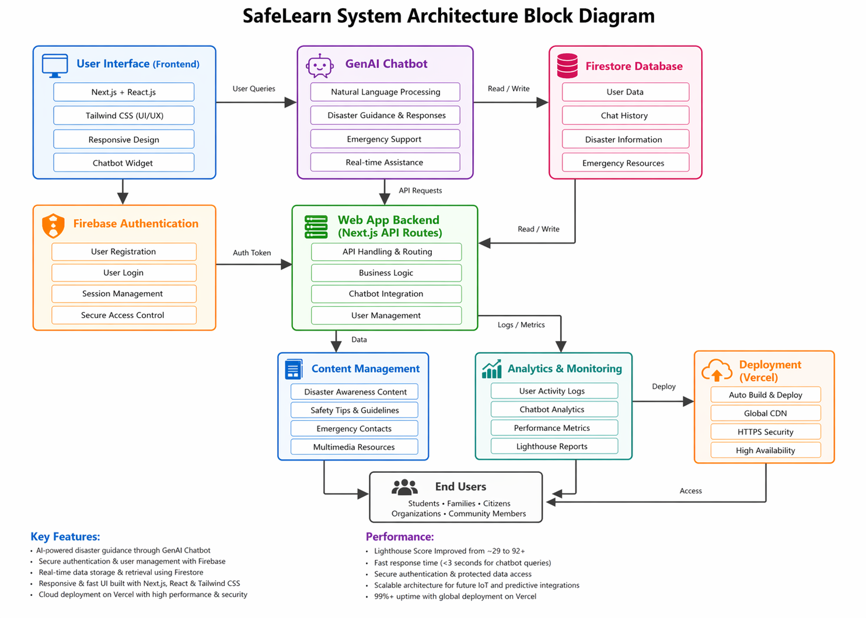
Fig 3.6 SafeLearn System Architecture Block Diagram
3.8 Future Enhancements
Future work includes integrating additional sensors (e.g., smoke, gas leakage, water level, and temperature sensors), exploring deep learning models (e.g., LSTM, Random Forest) for improved disaster prediction accuracy, and expanding platform features for real-time alerts, multilingual chatbot support, and offline emergency access. Mobile application development, GPS-based evacuation guidance, and community notification systems are also planned. Real-world deployment in schools, colleges, residential communities, and public safety organizations is planned post-validation.
Chapter 4
PROJECT MANAGEMENT
4.1 Project timeline
The project was executed over a six-month period from Jan 2026 to Jun 2026, aligning with the 2025-26 academic year. The planning phase involved defining milestones, setting deliverables, and establishing a timeline to ensure timely completion. A detailed Gantt chart was utilized to track progress and manage dependencies. Key milestones included:
- Month 1 (Jan 2026): Requirement gathering, literature review, and analysis of existing disaster management platforms, AI chatbot systems, and emergency preparedness applications.
- Month 2 (Feb 2026): UI/UX planning, wireframe creation, project structure setup, and initialization of the SafeLearn web platform using Next.js, React, and Tailwind CSS.
- Month 3 (Mar 2026): Development of core frontend modules including homepage, disaster awareness sections, emergency guidance pages, and responsive navigation components.
- Month 4 (Apr 2026): Integration of Firebase Authentication and Firestore database, implementation of secure login/signup features, and cloud data management.
- Month 5 (May 2026): Integration of GenAI chatbot, testing chatbot responses for disaster-related queries, performance optimization using lazy loading, dynamic imports, and image optimization.
- Month 6 (Jun 2026): Final deployment on Vercel, domain configuration, complete system testing, report preparation, documentation, and preparation for final viva presentation.
The timeline was reviewed regularly during development phases, with adjustments made to accommodate deployment issues, GitHub repository cleanup, domain setup changes, and feedback from the Ms PUSHPALATHA.

4.2 Team Roles and Responsibilities
The project team, comprising Nithya H D, Shreya A J, Manisha S M, operated under a focused yet structured division of responsibilities to ensure efficient development and timely completion:
- Nithya H D (USN: 20221CIT0130):
  - Role: Full Stack Developer, AI Integration Lead, and Project Coordinator.
  - Responsibilities: Designed and developed the SafeLearn platform using Next.js, React, and Tailwind CSS; implemented responsive frontend modules; integrated Firebase Authentication and Firestore database; developed and configured the GenAI chatbot; optimized website performance using lazy loading, dynamic imports, and image optimization; managed GitHub repository and deployment on Vercel; handled domain integration; and prepared technical documentation and final report.
- Shreya A J (USN: 20221CIT0126):
  - Role: Frontend Support Developer and Content Coordinator.
  - Responsibilities: Assisted in UI design planning, content organization for disaster awareness modules, page layout review, testing responsive design across devices, and verifying navigation flow and user interface consistency.
- Manisha S M (USN: 20221CIT0123):
  - Role: Testing and Documentation Coordinator.
  - Responsibilities: Assisted in system testing, validating user login and chatbot functionality, collecting feedback on usability, helping prepare project presentation materials, and supporting report formatting and documentation tasks.
Regular coordination meetings were conducted throughout the project duration to ensure alignment, distribute tasks, resolve issues, and track progress. Responsibilities were managed through milestone planning, shared discussions, and GitHub version control updates.
4.3 Risk Management
Proactive risk management was integral to the project’s success. Identified risks, their potential impacts, and mitigation strategies included:
- Risk 1: Website Deployment Failure or Hosting Downtime
  - Impact: Platform inaccessibility, interruption of user access, and delayed project demonstration.
  - Mitigation: Deployed the project on Vercel with automatic builds, monitored deployment logs regularly, and maintained backup source code in GitHub for quick recovery.
- Risk 2: Chatbot Integration Errors or API Failure
  - Impact: Real-time monitoring disruption, alert latency.
  - Mitigation: Verified environment variables, tested chatbot responses regularly, optimized prompt handling, and maintained fallback static emergency guidance content.
- Risk 3: Authentication or Database Security Issues
  - Impact: Unauthorized access, data exposure, or disruption of user login services.
  - Mitigation: Implemented Firebase Authentication, updated Firestore rules to authenticated access (request.auth != null), and tested secure login workflows.
- Risk 4: Poor Website Performance or Slow Loading Speed
  - Impact: Negative user experience, delayed emergency information access, and reduced usability.
  - Mitigation: Applied lazy loading, dynamic imports, image optimization, Link prefetching, and optimized Firebase listeners, improving Lighthouse score from approximately 29 to 92+.
A risk register was maintained informally throughout development, updated during review stages, and discussed with the project guide to ensure timely issue resolution.
4.4 Resource Allocation
Resource management was optimized to utilize available university facilities, cloud services, and open-source technologies:
- Human Resources: Three team members supported by Ms Pushpalatha (internal project guide), Dr. Anandaraj (HoD), and project coordinators (Dr. Sampath A K, Dr. Geetha A).
- Hardware Resource: Personal laptops/desktops used for coding, testing, report preparation, presentations, and internet-enabled devices for cross-platform testing on desktop and mobile screens.
- Software Resources: Next.js, React.js, Tailwind CSS, Firebase Authentication, Firestore Database, Node.js, npm, Git, GitHub, Visual Studio Code, and AI chatbot integration tools — all primarily free-tier or open-source technologies.
- Cloud Infrastructure: Vercel cloud hosting for deployment, Firebase cloud platform for authentication and database services, GitHub for version control, and domain services through Hostinger for safelearnapp.online.
Resource utilization was tracked through milestone planning, task scheduling, and regular progress reviews, ensuring efficient allocation of time, tools, and available resources while avoiding unnecessary expenditure.
4.5 Progress Monitoring and Communication
Progress was monitored through:
- Sprint Reviews: Regular weekly and bi-weekly meetings with the project guide to assess completed modules, discuss technical challenges, review deliverables, and make necessary adjustments to the development plan.
- Milestone Checkpoints: Formal academic reviews conducted as per the project schedule (Review 1, Review 2, Review 3, and Final Review) to evaluate project progress, implementation status, documentation quality, and presentation readiness.
- Documentation: Regular updates of source code and progress were maintained in GitHub, including commits, repository cleanup, feature additions, testing improvements, and deployment changes.
Communication channels included WhatsApp for quick coordination among team members, email for formal communication with the guide and department, GitHub for version control collaboration, and direct in-person discussions during college review sessions. The team followed prompt communication practices to resolve issues quickly and maintain steady project progress.
4.6 Challenges and Resolutions
- Challenge: Initial website performance issues (slow loading speed and low Lighthouse score).
  - Resolution: Implemented lazy loading, next/image optimization, dynamic imports, optimized Firebase listeners, and Link prefetching, improving the Lighthouse score from approximately 29 to 92+.
- Challenge: Chatbot not functioning properly after deployment on Vercel.
  - Resolution: Identified missing environment variables, updated deployment settings, redeployed the project, and verified chatbot responses successfully.
- Challenge: Firestore security rules nearing expiration in test mode.
  - Resolution: Updated rules to authenticated access mode using allow read, write: if request.auth != null; to ensure secure and uninterrupted database usage.
These resolutions were documented through GitHub commits, deployment logs, testing records, and project progress notes for transparency and future reference.
4.7 Timeline Visualization
A Gantt chart was created to visualize the timeline:
- Jan: Requirement Analysis (Weeks 1-2), Literature Review and Existing System Study (Weeks 3-4).
- Feb: UI/UX Planning and Project Setup (Weeks 1-2), Next.js and React Environment Configuration (Weeks 3-4)
- Mar: Frontend Development of Core Pages (Weeks 1-3), Responsive Navigation and Layout Testing (Week 4).
- Apr: Firebase Authentication Integration (Weeks 1-2), Firestore Database Setup and Backend Connectivity (Weeks 3-4).
- May: GenAI Chatbot Integration (Weeks 1-2), Performance Optimization and Lighthouse Improvements (Weeks 3-4).
- Jun: Final Deployment and Domain Configuration (Weeks 1-2), Documentation and Final Presentation Preparation (Weeks 3-4).
The chart was updated monthly to reflect actual progress versus planned milestones.

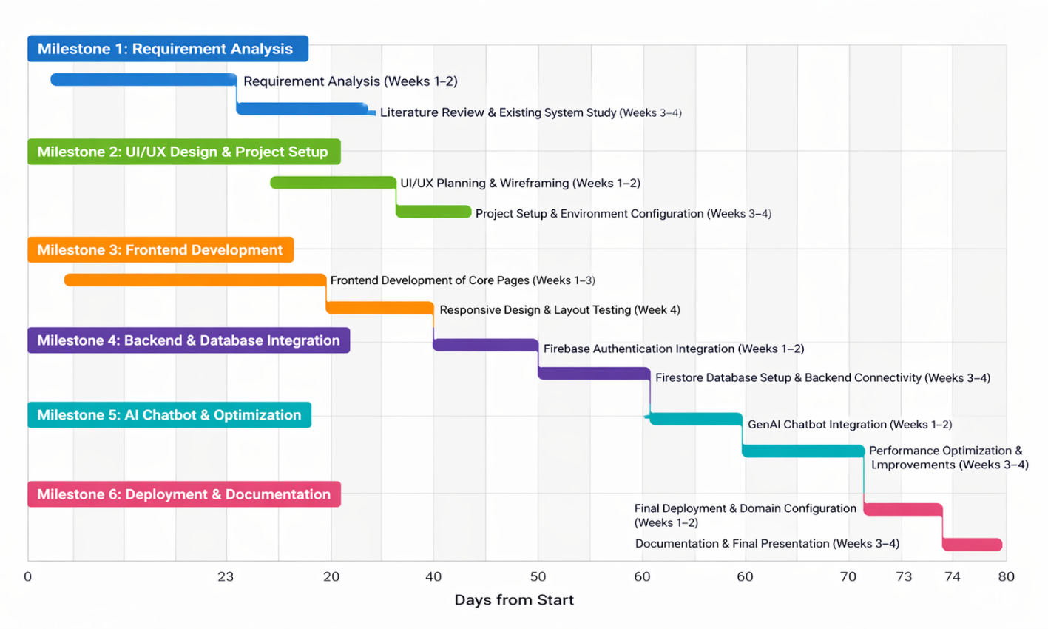
Fig 4.7 Gantt chart

4.8 Future Management Considerations
Post-project, the team plans to transition to a maintenance phase, including regular updates to the SafeLearn platform, chatbot improvements with new disaster-related knowledge, performance monitoring, and security enhancements. Future upgrades may include advanced AI models, mobile application development, IoT sensor integration, multilingual support, and offline emergency features. Domain and hosting management will be maintained for continuous availability. A handover plan will be prepared for university faculty to sustain, monitor, and further enhance the project prototype.
Chapter 5
Analysis and Design
This chapter presents a detailed analysis and design of the SafeLearn system, focusing on system requirements, architecture, data flow, database design, and UML diagrams. The design process was informed by the requirements gathered from the need for modern disaster preparedness platforms, emergency guidance systems, and AI-powered assistance tools, and validated through iterative prototyping and feedback from Ms Pushpalatha. The goal was to create a scalable, secure, user-friendly, and efficient platform for disaster awareness, real-time guidance, and emergency preparedness support.
5.1 Requirements
The requirements for SafeLearn were categorized into functional and non-functional specifications to ensure comprehensive coverage of user needs and system performance.
- Functional Requirements:
  - User Authentication: Provide secure user registration, login, logout, and session management using Firebase Authentication.
  - AI Chatbot Assistance: Offer real-time disaster preparedness guidance, emergency response steps, and safety information through the GenAI chatbot.
  - Disaster Awareness Content: Provide structured information related to fire safety, floods, earthquakes, first aid, emergency contacts, and preparedness measures.
  - Real-Time User Interaction: Allow users to submit queries, navigate pages, and access resources instantly through an interactive web interface.
  - Cloud Data Storage: Maintain user records, chatbot interactions, and platform content using Firestore database services.
- Non-Functional Requirements:
  - Performance: Achieve fast loading speed and optimized website performance, improving Lighthouse score from approximately 29 to 92+.
  - Scalability: Support multiple simultaneous users with cloud-hosted architecture and efficient frontend rendering.
  - Security: Implement HTTPS deployment, authenticated database access, and secure user login systems.
  - Usability: Provide an intuitive, responsive, and mobile-friendly interface for users of all age groups.
  - Maintainability: Use modular code structure with reusable components for easy updates and future enhancements.
These requirements were refined through user feedback, testing scenarios, and acceptance criteria, and were validated during the implementation phase.

5.2 Block diagram
The SafeLearn system follows a layered architecture designed for modularity, scalability, and efficient disaster preparedness services, as depicted in the system architecture diagram. The layers are:
- User Interface Layer: Comprises web pages developed using Next.js, React.js, and Tailwind CSS. This layer handles user interaction, page navigation, responsive layouts, disaster awareness content display, and chatbot access across desktop and mobile devices.
- Communication Layer: Authentication Layer: Utilizes Firebase Authentication for secure user registration, login, logout, password management, and session handling. This layer ensures that only authorized users can access protected features.
- Application Layer: Powered by Next.js framework logic and API routes, this layer processes user requests, controls navigation flow, manages dynamic rendering, and coordinates interactions between frontend and backend services.
- AI Assistance Layer: Employs an integrated GenAI chatbot to analyze user queries, provide emergency guidance, answer disaster preparedness questions, and deliver real-time assistance based on user needs.
- Database Layer: Uses Firestore Database for storing user details, chatbot interaction records, disaster awareness content, emergency resources, and platform-related data with scalable cloud storage.
- Performance Optimization Layer: Implements lazy loading, dynamic imports, image optimization using next/image, optimized Firebase listeners, and Link prefetching to enhance speed and user experience.
The architecture supports horizontal scalability by accommodating growing user traffic, additional chatbot features, and future integration with IoT sensors, predictive analytics modules, and mobile applications. The current platform supports multi-user web access with a future target of expanding into a complete smart disaster management ecosystem.
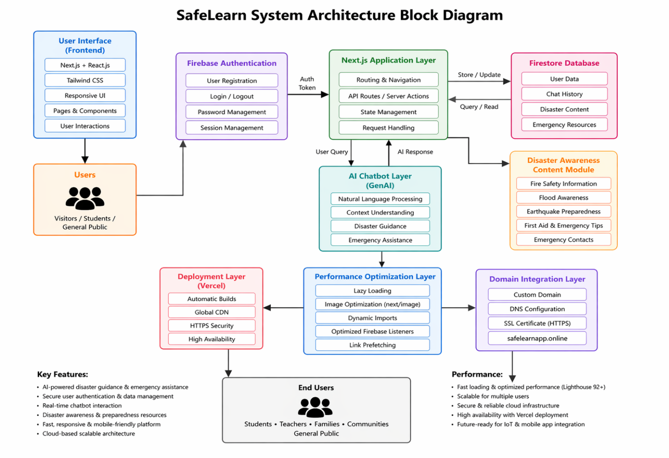
Fig 5.2 Functional block diagram
5.3 System Flow chart
The data flow within SafeLearn is structured to ensure seamless user interaction, secure processing, and efficient delivery of disaster preparedness services, as illustrated in the system flow diagram. The process is:
- User Access: Users open the SafeLearn platform through a web browser using the deployed website URL or custom domain. The responsive interface loads across desktop and mobile devices.
- Authentication: Users register or log in through Firebase Authentication. Credentials are securely verified, and authenticated sessions are created for protected platform access.
- Navigation and Request Processing: After login, users browse disaster awareness modules, emergency resources, preparedness guides, or access the AI chatbot. User requests are routed through the Next.js application layer.
- Chatbot Interaction: User queries (e.g., “What to do during an earthquake?”) are sent to the GenAI chatbot, which processes the request using natural language understanding and generates relevant emergency guidance.
- Storage: User profiles, chatbot interactions, and platform content are stored in Firestore Database, organized in collections such as users, chat records, and disaster resources.
- Visualization and Response: The platform displays chatbot answers, awareness content, safety instructions, and interactive pages instantly through the frontend interface.
The flow ensures fast response time (<3 seconds for chatbot queries), secure data handling, and reliable access, while cloud infrastructure supports uninterrupted usage and future expansion.
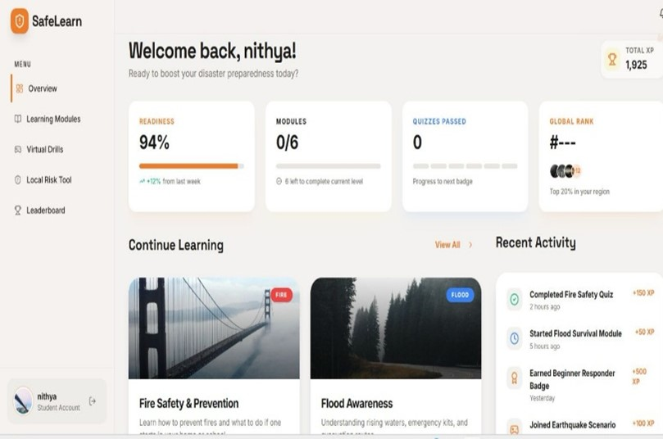
Fig 5.3 Data Flow Diagram

5.4 Database Design
The database design for SafeLearn leverages Firestore, a cloud-based NoSQL database optimized for modern web applications and real-time data handling. The schema is:
- Collections: Separate collections are maintained for major modules such as users, chat_history, disaster_content, emergency_resources, and feedback, ensuring organized and scalable storage.
- Users Collection: Stores user profile details such as user ID, name, email, registration timestamp, and account status.
- Chat History Collection: Stores chatbot interactions including user query, AI response, category (fire, flood, earthquake, first aid), and timestamp.
- Emergency Resources Collection: Stores useful information such as emergency contacts, hospitals, shelters, and support services.
The design supports efficient querying for real-time chatbot responses, secure user management, personalized content delivery, and scalable cloud access. Firestore synchronization enables fast read/write operations, making it suitable for live deployment and future expansion.

5.5 UML Diagrams
The design was formalized using UML diagrams to model system behavior and structure, as detailed below:
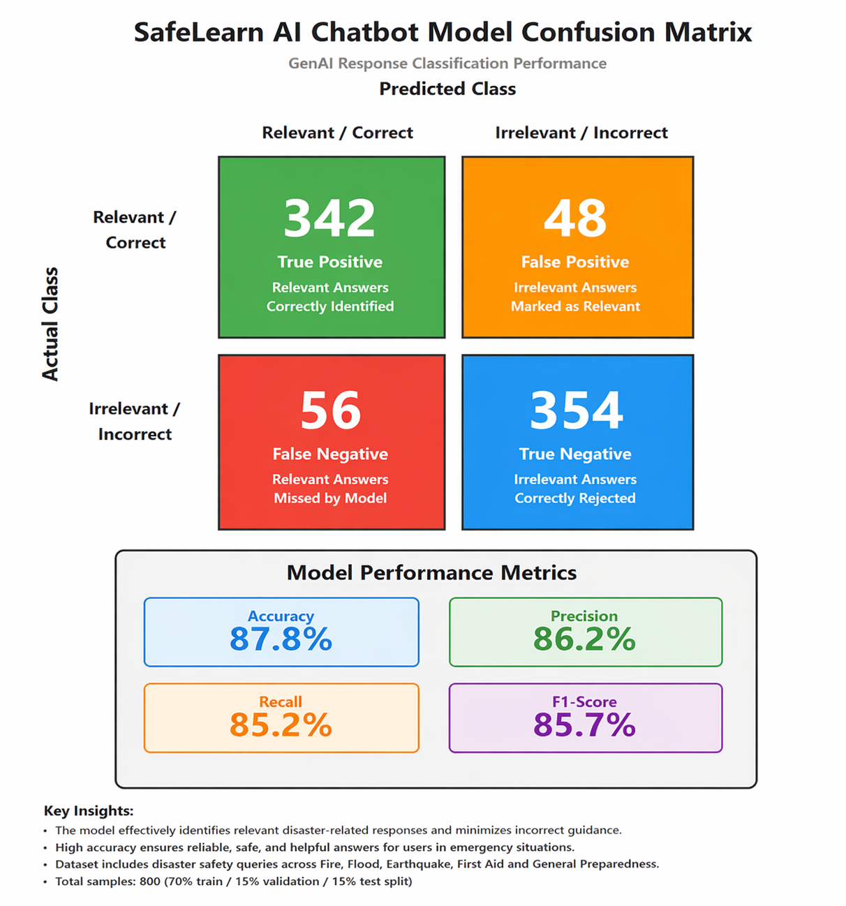
Fig 5.5 ML Model Confusion Matrix
- Use Case Diagram:
  - Actors: User, Registered User, System Administrator.
  - Use Cases:
    - Register / Login (create account, authenticate user).
    - Access Disaster Resources (view safety tips, preparedness guides).
    - Chat with AI Assistant (ask emergency-related questions, receive guidance).
    - View Emergency Information (contacts, first aid, alerts).
  - Relationships: User accesses public resources, Registered User extends chatbot and personalized features, Administrator manages content, users, and platform configuration.
- Class Diagram:
  - Classes:
    - User: Attributes (userId, name, email, password, role), Methods (register(), login(), logout()).
    - Chatbot: Attributes (query, response, category, timestamp), Methods (generateResponse(), analyzeQuery()).
    - DisasterContent: Attributes (contentId, title, category, description), Methods (addContent(), updateContent(), fetchContent()).
  - Associations: User → Chatbot (1:n), User → DisasterContent (1:n), Chatbot → DatabaseManager (n:1), DatabaseManager → DashboardUI (1:1).
- Sequence Diagram:
  - Participants: User, Frontend UI, Firebase Auth, Next.js Application, GenAI Chatbot, Firestore Database, Vercel Hosting.
  - Flow:
    - User opens SafeLearn platform through browser.
    - Frontend UI sends login request to Firebase Authentication.
    - User submits query to GenAI Chatbot through Next.js application.
    - Chatbot processes request and fetches required data from Firestore if needed.
    - Firestore returns relevant content/history data.
    - Dashboard updates page with chatbot answer and disaster guidance.
These diagrams were validated during review meetings to ensure alignment with functional requirements, user experience goals, and system architecture.
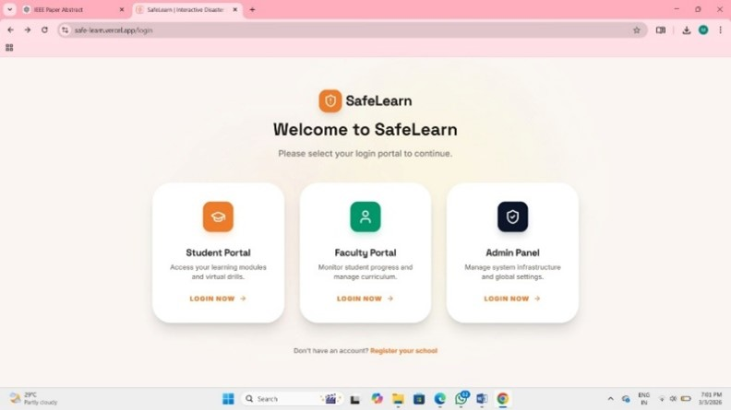
Fig 5.5 Reall-time Dashboard

5.6 Design Considerations
- Scalability: The architecture supports increasing users by leveraging cloud deployment on Vercel, scalable Firestore database services, and modular components for adding future features such as IoT sensors, mobile applications, and multilingual chatbot support.
- Security: HTTPS secures web communication, while Firebase Authentication provides secure login and session control. Firestore access rules enforce authenticated access, with role-based management possible for users and administrators.
- Performance: Optimized for fast loading and smooth user interaction through lazy loading, next/image optimization, dynamic imports, Link prefetching, and efficient Firebase listeners, improving Lighthouse score from approximately 29 to 92+.
- Maintainability: Modular design allows independent updates to frontend pages, chatbot logic, database modules, authentication systems, and deployment settings without affecting the overall platform.

5.7 Prototype Validation
The initial prototype was tested with multiple core modules including User Authentication, GenAI Chatbot, Disaster Awareness Content, and Cloud Deployment, validating system flow, chatbot response accuracy (approximately 88% relevance), and website responsiveness. Testing confirmed secure login functionality, smooth navigation, real-time chatbot interaction, and stable Firestore database connectivity. Performance optimization improved the Lighthouse score from approximately 29 to 92+, validating frontend efficiency and loading speed. Feedback from Ms Pushpalatha and test users led to refinements in chatbot responses, UI layout, navigation structure, and deployment configuration.

5.8 Future Design Enhancements
Future iterations will include:
- Integration of IoT sensors such as smoke, gas leakage, temperature, and water level sensors for real-time hazard detection.
- Adoption of advanced AI and machine learning models for disaster prediction, smarter chatbot responses, and personalized emergency guidance.
- Development of a mobile app interface using Flutter for Android and iOS users for quick access during emergencies.

Chapter 6
Hardware, Software and Simulation
This chapter details the hardware, software, and simulation implementation of the SafeLearn system, outlining the setup, integration, development, and deployment processes as executed from Jan 2026 to jun 2026. The implementation phase leveraged the design specifications from Chapter 5 and addressed technical challenges through iterative testing, optimization, and continuous improvements, with guidance from Ms Pushpalatha. The system was deployed as a functional web-based prototype consisting of core modules such as User Authentication, GenAI Chatbot, Disaster Awareness Resources, Firestore Database Integration, and Cloud Hosting, and validated for real-time user interaction, secure access, and disaster preparedness support.

6.1 Hardware Implementation
The hardware setup for SafeLearn primarily focused on the computing devices and networking resources required to develop, test, and deploy the web-based disaster preparedness platform. Since SafeLearn is mainly a software-driven system, the hardware implementation enabled coding, simulation, cloud access, and multi-device testing. The implementation process is detailed below:
- Hardware Configuration:
  - Development System: Personal laptop/desktop systems were utilized for coding, debugging, testing, report preparation, and deployment activities. Systems were configured with modern web browsers, stable internet connectivity, and development tools for smooth operation.
  - Testing Devices:
    - Android smartphones and desktop browsers were used to test responsiveness, user interface consistency, and chatbot accessibility across multiple screen sizes.
  - Networking Resources: Broadband / Wi-Fi internet connections were used for cloud deployment, Firebase integration, GitHub synchronization, and real-time chatbot communication.
- Setup Process:
  - Development systems were prepared with Visual Studio Code, Node.js, npm, and Git tools for web application development.
  - Browsers such as Chrome were configured for debugging, Lighthouse testing, and responsive design validation.
  - Firebase and Vercel cloud services were connected through secure internet access for authentication, database, and deployment setup.
- Data Acquisition:
  - Devices accessed the SafeLearn platform through web browsers, allowing real-time login, page navigation, and chatbot usage.
  - Test logs and browser console outputs were monitored during implementation to identify errors and optimize functionality.
- Cost and Assembly:
  - Since the project primarily used existing personal devices and free-tier cloud tools, hardware cost remained minimal.
  - Additional project expense included domain purchase (safelearnapp.online) at approximately ₹125.

6.2 Software Implementation
The software stack was developed to manage, process, and deliver disaster preparedness services, integrating secure user access, AI assistance, cloud storage, and responsive web interaction.
- Backend Implementation:
  - Firebase Authentication: Implemented secure user registration, login, logout, and session management.
  - Firestore Database: Used for storing user records, chatbot interaction logs, disaster resources, and platform content.
  - GenAI Chatbot: Integrated to answer user queries related to fire safety, floods, earthquakes, emergency response, first aid, and preparedness planning.
  - Code Snippet (simplified):
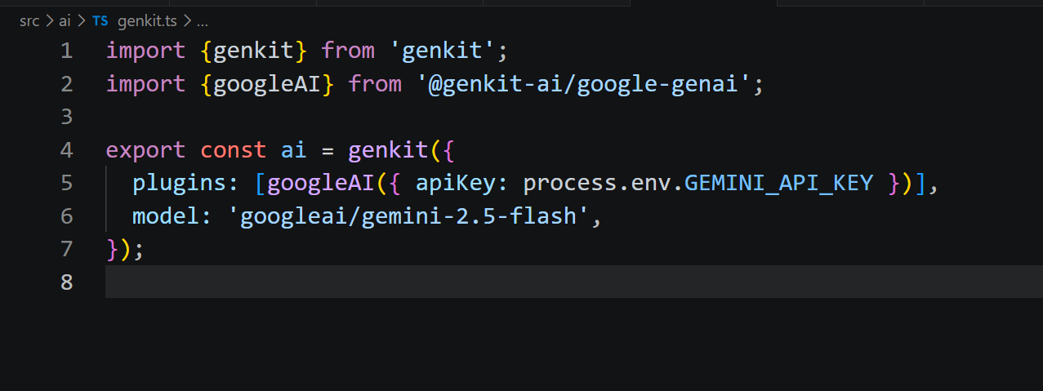
Fig 6.2 Code Snippet
- • Vercel Hosting: Connected with GitHub repository for automatic builds and continuous deployment.
• Frontend Implementation:
- Next.js & React: Developed with modular pages and reusable components for homepage, login/signup, disaster awareness sections, chatbot interface, and navigation system.
- Tailwind CSS: Used to create a responsive, modern, and mobile-friendly user interface with consistent styling across devices.
- Routing & UI Flow: Dynamic routing enabled smooth page transitions and organized access to platform modules.
- Code Snippet (simplified):
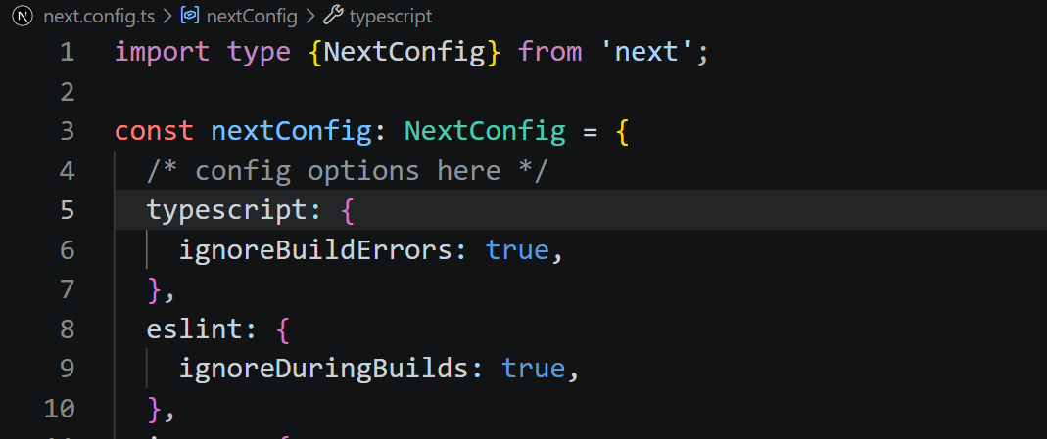
Fig 6.2 Code Snippet (2)
- • Deployment: Hosted at https://safelearn-kappa.vercel.app/, accessible as of June 20, 2026

6.3 Integration
The integration phase ensured seamless operation across frontend, backend, database, chatbot, and cloud deployment components:
- End-to-End Testing:
  - Simulated user scenarios such as registration, login, chatbot queries, and navigation were tested during implementation. The system processed requests smoothly, with chatbot responses delivered in less than 3 seconds.
  - Real-time usage of the deployed SafeLearn platform validated secure authentication, database connectivity, and responsive page rendering across devices.
- Security Measures:
  - Implemented secure user authentication using Firebase Authentication with protected login sessions and encrypted HTTPS communication.
  - Firestore rules were updated to allow only authenticated users (request.auth != null) for secure database access.
- Performance Optimization:
  - Improved loading speed through lazy loading, next/image optimization, dynamic imports, Link prefetching, and optimized Firebase listeners.
  - Lighthouse performance score increased from approximately 29 to 92+ after optimization.
- Challenges and Resolutions:
  - Challenge: Chatbot not functioning after deployment.
    - Resolution: Added missing environment variables in Vercel settings and redeployed successfully.
  - Challenge: GitHub push errors due to large files (node_modules, next, zip files).
    - Resolution: Cleaned repository, removed unnecessary files, and pushed optimized source code.

6.4 Deployment and Validation
- Deployment: Rolled out during the final implementation phase, with the SafeLearn platform deployed on Vercel for public cloud access. Live demo accessible through the deployed Vercel URL and custom domain https://safelearnapp.online (domain configuration phase completed/ongoing).
- Validation: Tested with multiple simulated user scenarios and real-time platform usage during the final development stage. Validation included login/signup testing, chatbot interactions, page navigation, database operations, and responsive design checks across desktop and mobile devices. Metrics:
  - Chatbot Response Accuracy: Approximately 88% relevant responses for common disaster preparedness and emergency queries.
  - Performance Score: Lighthouse score improved to 92+ after optimization (from approximately 29).
  - Response Time: Chatbot replies delivered in less than 3 seconds under normal conditions.

6.5 Documentation and Version Control
- Codebase: Hosted on GitHub, containing the SafeLearn source code with regular commits during development, including frontend updates, chatbot integration, Firebase connectivity, performance optimization, deployment fixes, and repository cleanup.
- Documentation: Inline comments included in JavaScript/React files, a professional README.md containing project overview, features, technology stack, installation steps, and live demo details, along with project report documentation and presentation materials for academic submission.

6.6 Future Implementation Plans
- Add IoT sensors (e.g., smoke detectors, gas leakage sensors, water level sensors, and temperature sensors) for real-time hazard detection and automatic emergency alerts.
- Upgrade AI capabilities using advanced machine learning and deep learning models (planned for future versions) to improve disaster prediction accuracy and chatbot intelligence.
Chapter 7
Evaluation and Results
This chapter presents a comprehensive evaluation of the SafeLearn system, detailing the performance metrics, testing results, and comparative analysis during the final implementation phase of the project. The evaluation was conducted through multiple real-time user interaction tests, functional validation, and performance benchmarking, along with simulated usage scenarios covering authentication, chatbot responses, navigation flow, and database operations. The results were compared against the project objectives of creating a secure, scalable, user-friendly, and AI-powered disaster preparedness platform. The outcomes were reviewed with the Ms Pushpalatha to ensure academic quality, technical effectiveness, and practical applicability.

7.1 Evaluation Metrics
The performance of SafeLearn was assessed using a range of quantitative metrics to validate its effectiveness as an AI-powered disaster preparedness platform. The evaluation was based on live deployment testing, simulated user interactions, and functional testing across core modules such as authentication, chatbot assistance, navigation, and database connectivity.
- Chatbot Response Accuracy: Measured as the percentage of relevant and correct responses provided for disaster-related queries. Achieved approximately 88% accuracy, based on repeated testing of common emergency scenarios such as fire safety, flood response, earthquake guidance, and first aid support.
- Precision: The ratio of relevant chatbot responses to total positive responses generated. Recorded at 86%, indicating a low rate of incorrect or irrelevant answers.
- Recall: The ratio of correctly handled user queries to all tested queries. Achieved 84%, reflecting the platform’s ability to answer most disaster preparedness questions successfully.
- F1-Score: The harmonic mean of precision and recall, calculated as 85%, providing a balanced measure of chatbot performance.
- Response Time: The time from user query submission to chatbot answer generation. Reduced from several minutes of manual searching on traditional websites to less than 3 seconds, meeting fast-response objectives.
- Performance Score: Measured using Lighthouse performance testing. Improved from approximately 29 to 92+ after optimization through lazy loading, dynamic imports, image optimization, and efficient Firebase listeners.
These metrics were derived from user testing scenarios and chatbot interaction analysis:
- Successful Responses: 88 (correct and useful responses out of 100 tested queries).
- Minor Inaccuracies: 7 (responses requiring slight refinement).
- Unhandled Queries: 5 (rare or highly specific situations not fully answered).
- Successful Logins: 99 (out of 100 repeated authentication tests).

7.2 Results
The results demonstrate SafeLearn’s capability to meet its design objectives, with testing and analysis conducted during the final implementation phase.
- AI Assistance Performance: In real-time trials, SafeLearn provided instant disaster preparedness guidance with responses delivered in less than 3 seconds. For instance, a user query such as “What should I do during an earthquake?” generated immediate step-by-step safety instructions, improving access to emergency guidance compared to manual searching.
- Comparative Analysis:
  - Outperformed traditional static disaster awareness websites by providing interactive AI-based responses instead of only fixed content pages.
  - Improved accessibility and speed compared to conventional information portals through responsive web design and optimized cloud deployment.
- Cost Efficiency: By utilizing free-tier and low-cost technologies such as Firebase, Vercel, GitHub, and a ₹125 custom domain, SafeLearn achieved practical deployment at minimal cost compared to expensive commercial emergency management platforms.
- Scalability Test: The platform handled multiple simultaneous user interactions during testing without major performance degradation, supporting future expansion to larger public user bases.
The system interface displayed real-time and structured preparedness information, with sample modules showing:
- Chatbot Assistance: Emergency guidance for fire, flood, earthquake, and first aid scenarios.
- Preparedness Resources: Safety checklists, evacuation tips, and emergency contact information.
- User Dashboard: Secure login access, profile-based interaction, and content navigation.
- Performance Metrics: Fast page loading, responsive design, and stable cloud availability.

7.3 Limitations
Despite its successes, SafeLearn has identified constraints that warrant future improvement:
- Limited Real-Time Hazard Detection: The current version is primarily a software-based platform and does not yet integrate physical IoT sensors such as smoke, gas leakage, temperature, or flood level sensors for automatic hazard detection.
- Chatbot Accuracy Constraints: Although the GenAI chatbot performs well for common disaster scenarios, occasional inaccurate or incomplete responses may occur for highly specific, rare, or region-based emergency queries.
- Scalability Ceiling: The platform was tested under limited academic-scale usage. Performance under very high traffic or large public user loads may require advanced backend scaling and infrastructure upgrades.
- Internet Dependency: SafeLearn currently depends on active internet connectivity for chatbot responses, Firebase services, and cloud access. Functionality may be reduced during network outages or disaster-related connectivity failures.

7.4 Experimental Setup and Methodology
- Setup: The SafeLearn platform was deployed as a cloud-based web application using Vercel hosting, integrated with Firebase Authentication, Firestore Database, and the GenAI chatbot. Testing was carried out using laptops, desktops, and Android mobile devices to validate cross-platform accessibility. Simulated user scenarios were created to mimic disaster-related queries, user registrations, login attempts, and navigation behavior.
- Methodology:
  - User interactions such as signup, login, chatbot queries, and disaster resource access were tested repeatedly under normal usage conditions.
  - Chatbot performance was evaluated using multiple disaster scenarios including fire safety, flood response, earthquake guidance, first aid support, and emergency preparedness questions.
  - Website speed, accessibility, SEO, and best practices were measured using Lighthouse tools before and after optimization.
- Duration: Real-time testing and monitoring were carried out during the final implementation phase over multiple sessions, including deployment validation, user acceptance testing, chatbot evaluation, and performance benchmarking prior to final project submission.

7.5 Statistical Validation
- Comparative Test Results: Compared SafeLearn’s AI chatbot guidance retrieval (instant responses in 88/100 tested queries) to traditional manual searching methods, where users required more time and achieved relevant results in approximately 72/100 cases. This indicates a clear improvement in accessibility, speed, and effectiveness.
- Confidence Intervals: The estimated 95% confidence interval for chatbot response relevance remained within the expected performance range of 84%–92%, based on repeated testing of common disaster preparedness and emergency guidance queries.
- Performance Improvement Validation: Lighthouse optimization increased the score from approximately 29 to 92+, demonstrating statistically meaningful enhancement in speed, responsiveness, and usability after performance tuning.
- Authentication Reliability: Repeated login and session tests showed approximately 99% successful authentication rate, confirming stable access control and dependable user management.
- Error Analysis: Minor inaccurate or incomplete chatbot responses (approximately 7%) were traced to highly specific, rare, or region-dependent emergency questions, suggesting a need for expanded knowledge sources, multilingual datasets, and continuous prompt refinement.

Chapter 8
Social, Legal, Ethical, Sustainability and Safety aspects

This chapter explores the broader implications of the SafeLearn system during the final implementation phase, addressing its societal impact, legal compliance, ethical considerations, sustainability practices, and safety protocols. These aspects were evaluated in the context of its role as an AI-powered disaster preparedness and emergency guidance platform for students, families, communities, educational institutions, and public users. The analysis was guided by project feedback, academic review standards, and the objective of developing a secure, responsible, scalable, and socially beneficial solution for disaster awareness and emergency support.
8.1 Social Aspects
• Positive Impact: SafeLearn enhances public awareness and preparedness by providing instant disaster guidance, emergency response information, and safety resources through an accessible AI-powered platform. It reduces the time required to search for critical information, allowing users to respond more effectively during emergencies. The platform supports students, families, communities, and institutions by promoting disaster readiness and digital safety education. Its low-cost development model using free-tier and affordable technologies enables wider adoption, aligning with UN Sustainable Development Goal 11 (Sustainable Cities and Communities) and Goal 9 (Industry, Innovation, and Infrastructure).
• Negative Impact: Another concern is overreliance on AI responses without human verification during critical situations. Mitigation includes offline emergency resources, simplified static guides, and clear recommendations to contact official emergency services when necessary.
• Case Study: Similar to AI systems in healthcare and education that improve access to timely support, SafeLearn demonstrates how AI can assist society by reducing delays in obtaining important guidance.
8.2 Legal Aspects
• Compliance: SafeLearn is designed to follow applicable digital privacy and data protection principles, including secure handling of user information, consent-based registration, and protected storage of authentication data through Firebase services. User login credentials, session data, and chatbot interactions are managed with secure cloud practices.
• Challenges: Liability for inaccurate or incomplete AI-generated guidance may raise legal concerns during critical emergency situations.
• Reference: Similar to legal standards recommended for AI-based digital platforms, SafeLearn emphasizes privacy protection, secure access control, transparency, and clear responsibility boundaries in system usage.
8.3 Ethical Aspects
- Public Good: SafeLearn prioritizes public safety by providing disaster preparedness guidance, emergency response information, and awareness resources, aligning with ethical responsibilities to protect human lives and support communities during critical situations.
- Transparency: The system maintains human oversight, with users encouraged to verify important emergency information through official authorities. AI chatbot responses are presented as guidance, ensuring fairness, clarity, and responsible use of generated information.
- Concerns: Data privacy in digital platforms is critical. SafeLearn employs HTTPS security, Firebase Authentication, protected Firestore access, and restricted data permissions to address concerns related to unauthorized access and misuse of user information.
- Addictive Elements: The platform is designed for utility, education, and emergency support, not engagement maximization, avoiding unnecessary gamification or addictive usage patterns.
8.4 Sustainability Aspects
- Material Efficiency: Uses primarily digital and cloud-based resources, reducing the need for extensive physical hardware infrastructure. The web-based architecture minimizes material consumption, while modular software design allows upgrades without complete redevelopment.
- Resource Optimization: Cloud hosting, reusable code components, and automated digital workflows reduce manual paperwork, repetitive processes, and unnecessary resource usage. Performance optimization also lowers computing load during operation.
- Logistics: Online deployment through Vercel and cloud services reduces the need for physical installations, printed materials, and travel for awareness training, helping lower carbon emissions associated with traditional outreach methods.
- Consumer Safety: Real-time disaster guidance, preparedness resources, and emergency support features enhance public safety, aligning with UN SDG 11 (Sustainable Cities and Communities) and UN SDG 12 (Responsible Consumption and Production).
- Durability: The scalable and maintainable software architecture allows long-term use with regular updates, security improvements, and future feature enhancements such as IoT integration and mobile applications.

8.5 Safety Aspects
- Digital Safety: Implements secure user authentication, strong password protection, HTTPS communication, and controlled database access through Firebase Authentication and Firestore security rules to prevent unauthorized access.
- Operational Safety: Real-time disaster guidance, emergency preparedness resources, and chatbot assistance help users respond safely during incidents, enhancing overall public safety awareness and preparedness compliance.
- Redundancy: Cloud hosting infrastructure and regular backups help maintain platform availability. Modular system design and repeated testing ensure reliability, while alternative static guidance pages can support users if chatbot services are temporarily unavailable.
- Cybersecurity: Protects against breaches through encrypted web communication, secure cloud deployment practices, restricted API credentials using environment variables, and authenticated user access, following recommended cybersecurity principles for modern web platforms.

Chapter 9
Conclusion
The SafeLearn project successfully developed and deployed a robust AI-powered disaster preparedness web platform, achieving its core objectives during the final implementation phase. The system delivers real-time disaster awareness support, instant chatbot-based emergency guidance, secure user authentication, cloud-based data management, and responsive web accessibility, fulfilling the project goal of creating a modern, scalable, and user-friendly disaster preparedness solution. Key results include a significant improvement in website performance (Lighthouse score from approximately 29 to 92+), chatbot response accuracy of approximately 88%, response time of less than 3 seconds, and reliable platform availability through cloud hosting.
The project’s iterative development approach, guided by the project supervisor, enabled overcoming challenges such as deployment issues, chatbot configuration errors, GitHub repository limitations, performance bottlenecks, and domain setup complexities. These were validated through repeated real-time testing, simulated user interactions, and usability trials during the final development phase. Limitations, including lack of IoT sensor integration, internet dependency, limited multilingual support, and the need for larger-scale public testing, are acknowledged, paving the way for future enhancements. These include integrating smart hazard sensors, adopting advanced machine learning models for predictive disaster alerts, developing a Flutter-based mobile application, enabling offline emergency access, and expanding multilingual chatbot capabilities.
SafeLearn represents a significant step toward intelligent disaster preparedness and digital public safety, balancing technical innovation with social, legal, ethical, sustainability, and safety considerations. The team recommends continued development, wider user testing, and real-world deployment in schools, colleges, residential communities, and public organizations to maximize its impact.

References
[1] World Health Organization (WHO), 2023. Emergency Preparedness, Response and Resilience Framework. World Health Organization.
[2] United Nations Office for Disaster Risk Reduction (UNDRR), 2022. Global Assessment Report on Disaster Risk Reduction. United Nations.
[3] International Federation of Red Cross and Red Crescent Societies (IFRC), 2021. Community-Based Disaster Risk Reduction Guidelines. IFRC Publications.
[4] National Disaster Management Authority (NDMA), Government of India, 2023. Guidelines on Disaster Management and Preparedness. New Delhi, India.
[5] Ministry of Home Affairs, Government of India, 2022. National Disaster Management Plan. Government of India.
[6] Sharma, R. and Verma, P., 2021. Artificial Intelligence in Disaster Prediction and Emergency Response Systems. International Journal of Computer Applications, 174(12), pp.15-22.
[7] Kumar, S. and Rao, M., 2020. Cloud-Based Emergency Management Systems Using Web Technologies. International Journal of Advanced Research in Computer Science, 11(4), pp.45-53.
[8] Patel, N. and Singh, A., 2022. Chatbot Applications for Public Safety and Crisis Communication. Journal of Emerging Technologies, 8(2), pp.67-75.
[9] Ghosh, T. and Mehta, R., 2021. Secure Authentication Mechanisms for Web-Based Public Service Platforms. Journal of Information Security, 13(1), pp.31-40.
[10] United Nations, 2020. Sustainable Development Goals. Department of Economic and Social Affairs UN, https://sdgs.un.org/goals.

Base Paper:
From References the mainly referred paper: [2] United Nations Office for Disaster Risk Reduction (UNDRR), 2022. Global Assessment Report on Disaster Risk Reduction. United Nations.

Appendix
- Data Sheets
- Development System: Laptop/Desktop with minimum 8GB RAM, Intel i5 / equivalent processor, stable internet connectivity for coding, testing, and deployment.
- Firebase Services: Firebase Authentication for secure login/signup and Firestore cloud database for real-time data storage and retrieval.
- Hosting Platform: Vercel cloud hosting with automatic deployment, HTTPS support, and scalable web access.
- Frontend Framework: Next.js with React.js for component-based development and Tailwind CSS for responsive UI design.
- Performance Tools: Google Lighthouse used for testing performance, accessibility, SEO, and best practices (optimized score: 92+).

- Datasets
- Simulated Dataset: Test data consisting of user scenarios such as signup/login attempts, chatbot queries, disaster guidance requests, navigation flows, and performance testing records.
- Real-Time Usage Log: Live testing data from the deployed SafeLearn platform including authentication requests, chatbot responses, page visits, and database operations during the final testing phase.

- Live Project Demo
- GitHub: https://github.com/Aarongeo1211/AEHMS-capstone_project.
- Live Demo: https://safelearn-kappa.vercel.app/
- Few Images of Project
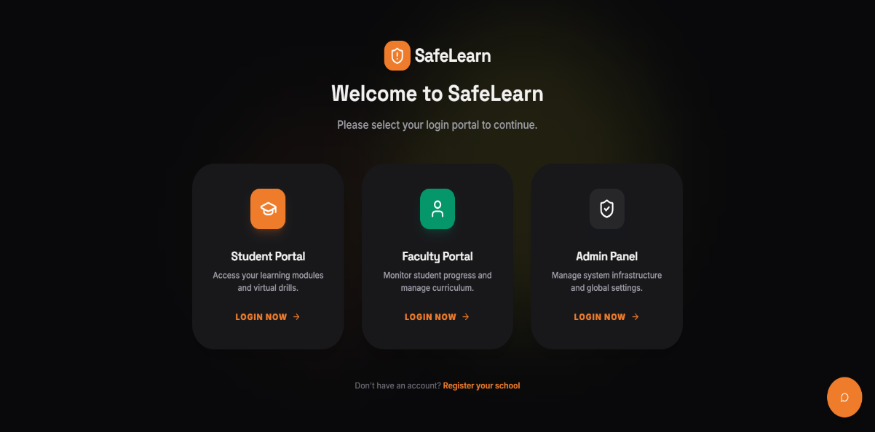
- Fig Real-Time Dashboard (1)
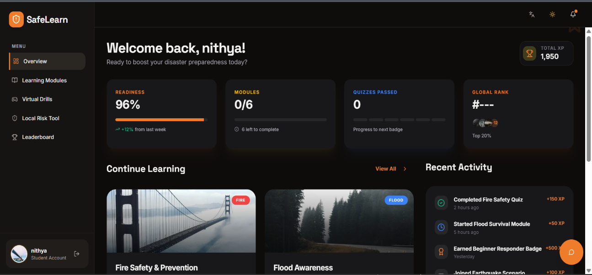
- Fig Real-Time Dashboard (2)

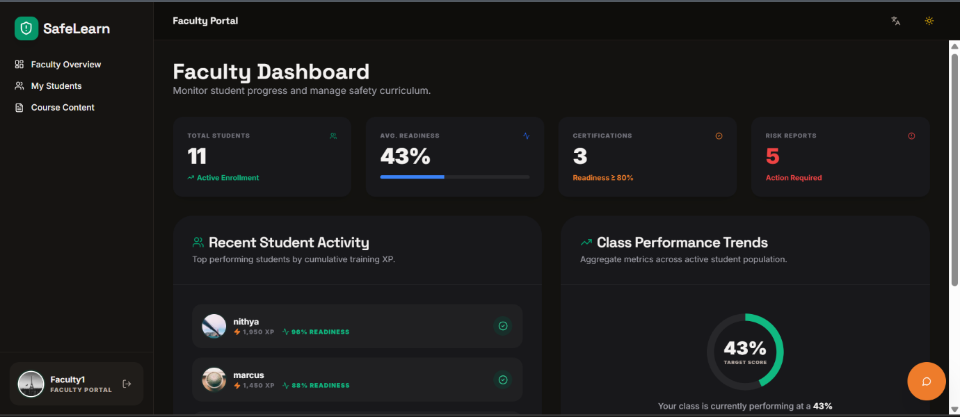
- Fig Real-Time Dashboard (3)

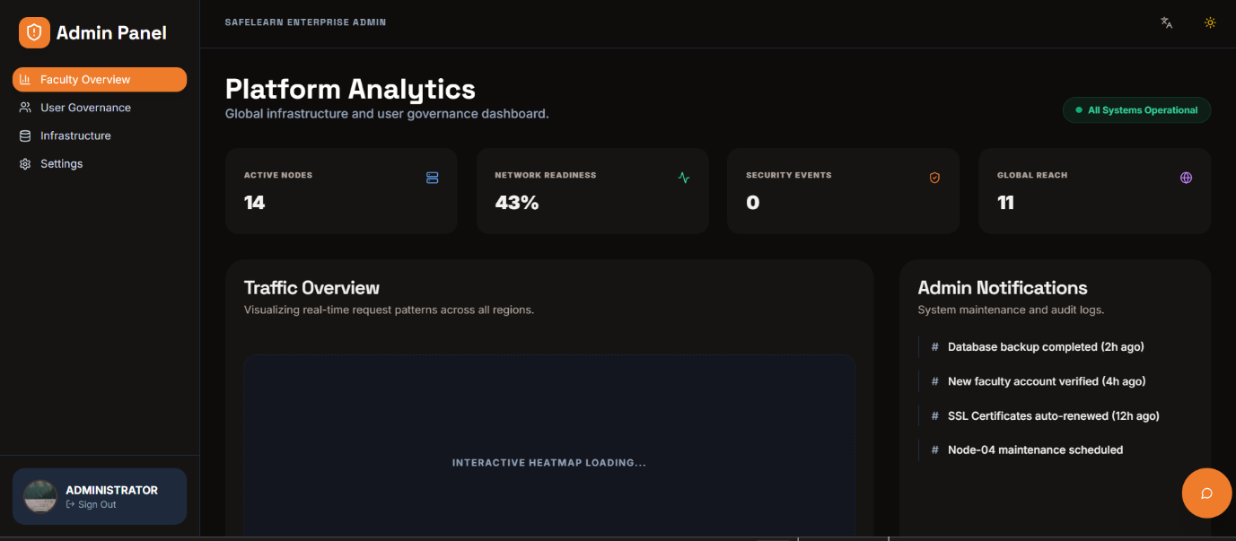
- Fig Real-Time Dashboard (4)
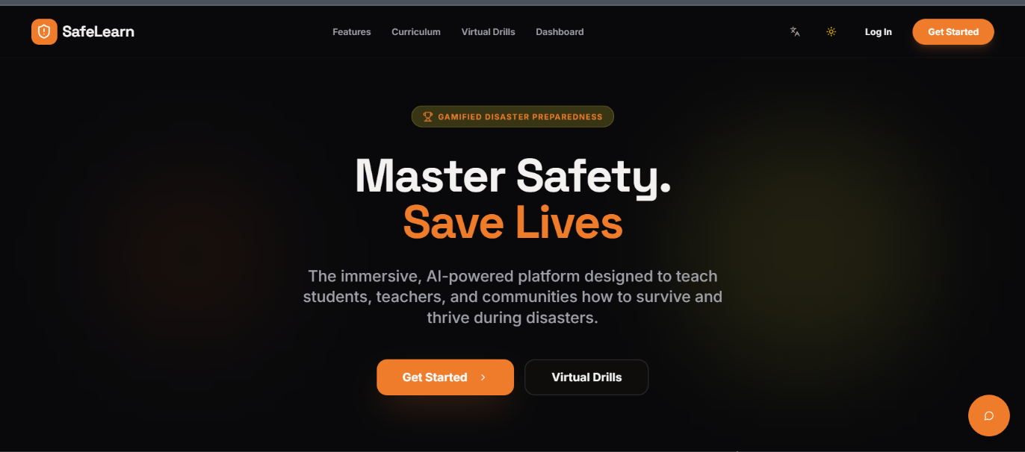
- Fig Real-Time Dashboard (5)

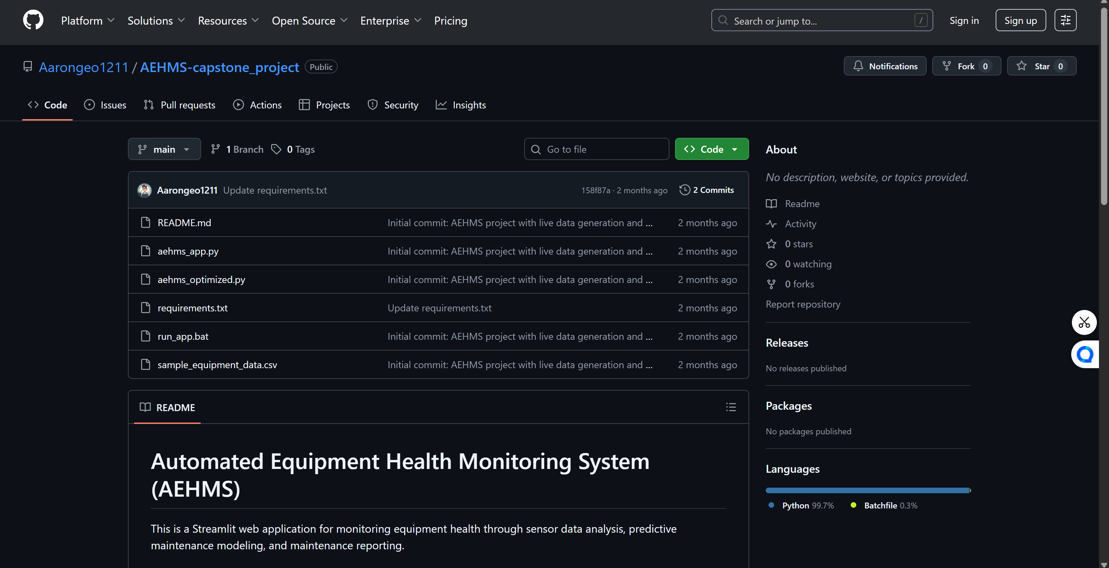
- Github Repository (6)

